Lo Mein

### **Ingredients**

* 2 Qts beef or chicken fat and sauce.
* 2 cups light soy sauce
* 1 tbsp dark soy sauce
* 2 tbtsp toasted sesame oil
* 3 tsp sugar
* 100g confit ginger
* 100 g Scallion butts

**Pickup**

* Salted Cabbage 50 gBraised beef
* 1 lb lo mein noodles
* 1 tbsp oil
* 4 cloves garlic **confit**
* 1 cup mushrooms **sliced**, crimini preferred
* 1 small carrot **pickjled**
* 1 cup snow brocolli
* 2-3 cup spinach baby spinach preferred
* green onions **thinly sliced**, to finish, as needed
* Togerashi
* Sesame seeds

### **Instructions**

1. In a small bowl or measuring cup, whisk together the soy sauces, sesame oil, sugar and ground ginger. Set aside.
2. 
3. Heat the oil over medium heat and add the garlic and cook, stirring occasionally until slighly golden.
4. 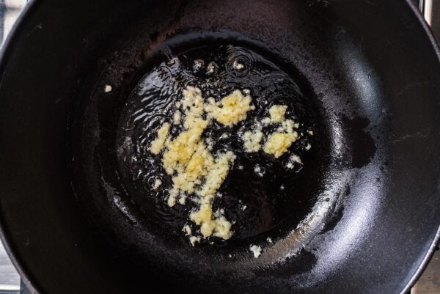
5. Turn up the heat to medium high and add the mushrooms, cooking and tossing occasionally, until soft.
6. 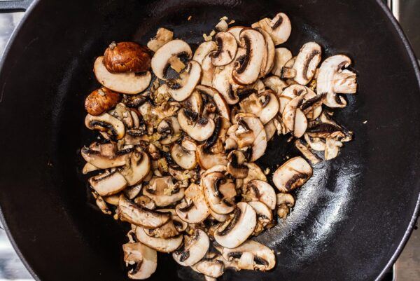
7. Add the carrots and snow peas and toss for 1-2 minutes, until tender crisp.
8. vegetable lo mein | www.iamafoodblog.com
9. Mix in the noodles, spinach, and sauce. Toss until well combined. Taste and season with salt, if desired. Sprinkle on the green onions and enjoy immediately.
10. 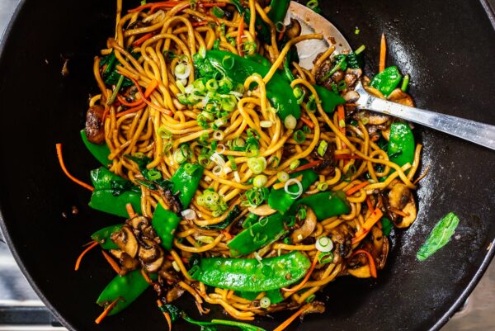

### **Notes**

Cook the lo mein or spaghetti according to the package. If you are using precooked lo mein noodles, loosen gently under hot tap water. Drain well.